Stock Data Analysis

This project has an aim to build visualisation dashboards to get an insight of the data. Following dashboard contains various widgets giving an overview of measures in data.

In this dashboard a slicer is implemented to filter data on company. Once a company is selected various measures such as open - close values, trends and monthly volumes are displayed.

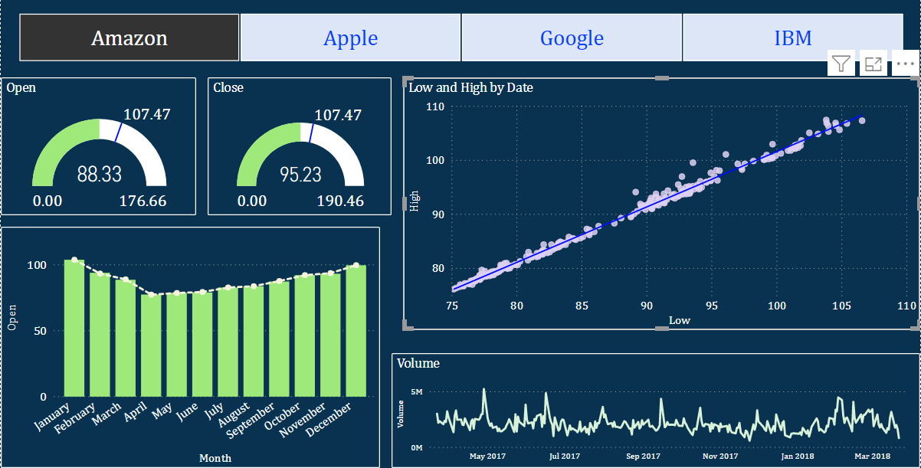

* Slicer - to select the company in the view



* Gauge - to show current open and close values

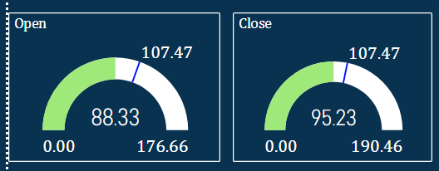

* Trend line - showing trend in high and low values

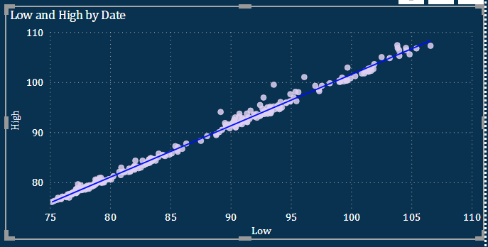

* Bar chart - showing monthly open and close

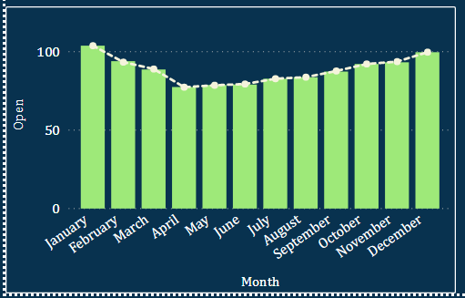

* Line chart - showing daily volumes

